Gabon

## GNI per capita and development level

The data set shows the GNI per capita and development level of the country each year.

## # A tibble: 19 x 5  
## country iso3c date GNIperCapita devCategory   
## <chr> <chr> <dbl> <dbl> <chr>   
## 1 Gabon GAB 1996 10712. Upper Middle Income  
## 2 Gabon GAB 1998 11494. Upper Middle Income  
## 3 Gabon GAB 2000 8879. Upper Middle Income  
## 4 Gabon GAB 2002 9467. Upper Middle Income  
## 5 Gabon GAB 2003 9289. Upper Middle Income  
## 6 Gabon GAB 2004 8563. Upper Middle Income  
## 7 Gabon GAB 2005 8995. Upper Middle Income  
## 8 Gabon GAB 2006 8053. Upper Middle Income  
## 9 Gabon GAB 2007 8102. Upper Middle Income  
## 10 Gabon GAB 2008 7457. Upper Middle Income  
## 11 Gabon GAB 2009 7819. Upper Middle Income  
## 12 Gabon GAB 2010 7687. Upper Middle Income  
## 13 Gabon GAB 2011 7606. Upper Middle Income  
## 14 Gabon GAB 2012 8262. Upper Middle Income  
## 15 Gabon GAB 2013 8545. Upper Middle Income  
## 16 Gabon GAB 2014 9309. Upper Middle Income  
## 17 Gabon GAB 2015 8995. Upper Middle Income  
## 18 Gabon GAB 2016 8997. Upper Middle Income  
## 19 Gabon GAB 2017 8925. Upper Middle Income

## GDP growth and economic growth classification

The data set shows the GDP growth and the ecomic growth classification of the country each year.

## # A tibble: 19 x 5  
## country iso3c date GDPannualGrowthRate GDPgrowthCategory4  
## <chr> <chr> <dbl> <dbl> <fct>   
## 1 Gabon GAB 1996 3.63 moderate growth   
## 2 Gabon GAB 1998 3.48 moderate growth   
## 3 Gabon GAB 2000 -1.88 negative grwoth   
## 4 Gabon GAB 2002 -0.249 negative grwoth   
## 5 Gabon GAB 2003 2.25 slow growth   
## 6 Gabon GAB 2004 0.690 slow growth   
## 7 Gabon GAB 2005 2.68 moderate growth   
## 8 Gabon GAB 2006 -2.81 negative grwoth   
## 9 Gabon GAB 2007 6.01 fast growth   
## 10 Gabon GAB 2008 -3.31 negative grwoth   
## 11 Gabon GAB 2009 0.130 slow growth   
## 12 Gabon GAB 2010 7.09 fast growth   
## 13 Gabon GAB 2011 7.09 fast growth   
## 14 Gabon GAB 2012 5.25 moderate growth   
## 15 Gabon GAB 2013 5.64 fast growth   
## 16 Gabon GAB 2014 4.31 moderate growth   
## 17 Gabon GAB 2015 3.88 moderate growth   
## 18 Gabon GAB 2016 2.09 slow growth   
## 19 Gabon GAB 2017 0.473 slow growth

## Development trend

The plot shows the development trend of the country.

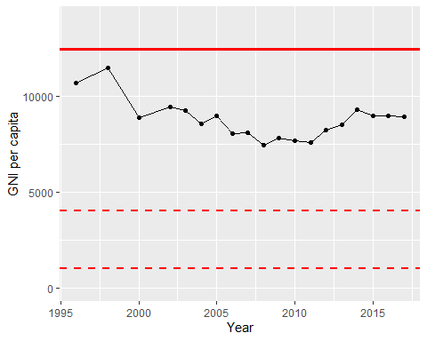

GNI Per Capita Trend